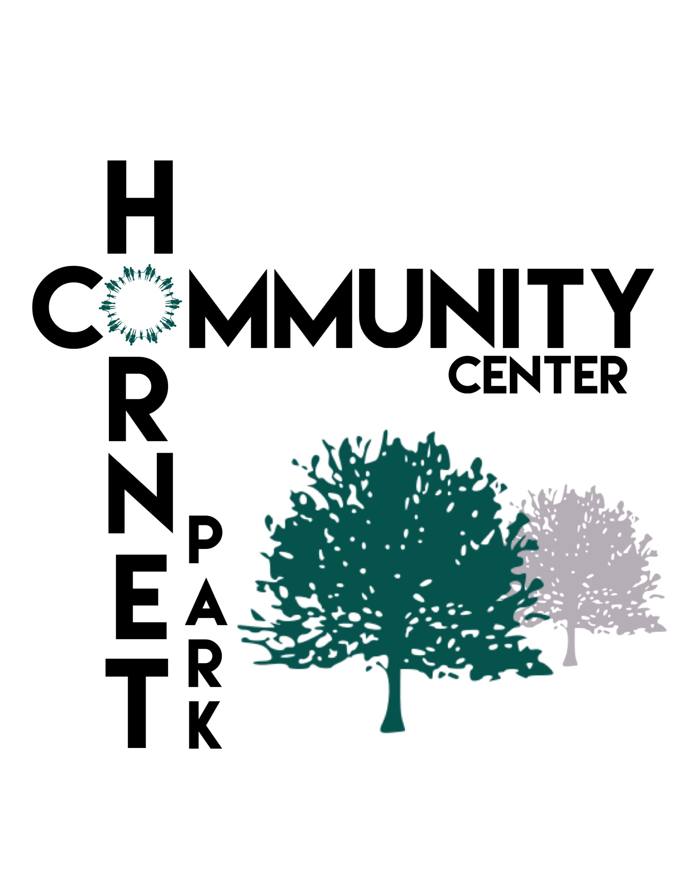
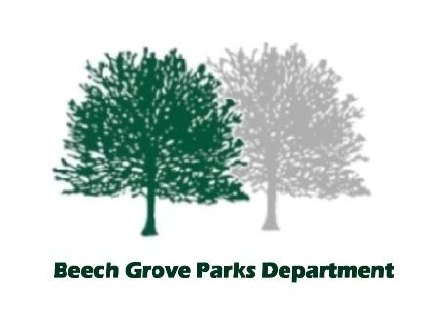

Summer Buzz Camp
2020

Welcome to Buzz Camp!
The mission of Buzz Camp is to facilitate a safe and fun environment for Beech Grove Students First through Eighth grade to grow and learn. It is our goal to help your student be academically, as well as socially, successful.
A partnership between Buzz Club staff and parents is very important. Communication is key to making sure your student is successful.

Fees:
Enrollment is for five days, Monday- Friday 7:30am-5pm.
In order to ensure your student’s spot, in addition to a completed registration application, a $10 deposit fee (per student) is required to be paid at enrollment.
A fee of $50 per week, per student is required to be paid in full by Monday, the first day of camp.
If payment is not received by this deadline, your student(s) will not be allowed to attend the program.

Cash or check is accepted payment. No credit cards will be accepted. NSF fee of $30 will be charged for any check returned.
All payments will be collected at the Hornet Park Community Center, only.

Enrollment: All paperwork will be taken to the Hornet Park Community Center. Each student will need to have separate paperwork filled out. Payments must be made by Monday of the week of camp. You must pay a full week deposit before your student can start. No credit or refund will be issued for your student being sick or being absent. Number of students enrolled in the program is limited, so it is highly encouraged to get your enrollment papers and fee submitted as soon as possible.

Schedule: Monday - Friday 7:30am-5pm. Drop off and pick up is at the Hornet Park Community Center.
Breakfast is served at 7:30am, all students must arrive by 8:30am
Please make any allergies known to the Buzz Club staff so accommodations can be provided.

Activities each week will focus on:
Nature
Animals
STEM
Leadership skills
Art
Music
Wellness
Sports and Recreation
Mindfulness
Buzz Camp calendar will be as follows:
June 8-12
June 15-19
June 22-26
June 29-July 3 (pick up on Friday 7/3 will be at 3pm)
July 6- 10
July 13-17
July 20-24

Pick Up: Pick up for your student will be at Hornet Park Community Center. You will need to show identification at the front desk and sign your child out, daily. Anyone picking up your child MUST be on the approved pick up list. All authorized persons must be at least 18 years old. You may add or change adults on your student’s pick up list at any time. In the event of custody situation, you must provide court documents showing proof of legal restrictions.
Your student MUST be picked up by 5:00 p.m. There will be a minimum late fee of $15 charged, with additional fees for every minute after 6:15. It is very important you pick your student up on time. Please call 317-803-9085 if a situation occurs.

Disciplinary Expectation: It is top priority that Buzz Club provides a safe environment for all students and staff. All school rules apply while your student is attending the program. A zero tolerance policy for bullying will be enforced at the program. The following disciplinary action will be taken:

- Verbal warning: Staff will discuss and help redirect the child to positive behavior.
- Written warning home to person picking up child.
- After three written warnings your child will be suspended from program. A phone call to parent will be made. Child will not be allowed back in to program until behavior issue has been formally addressed by phone conference or face to face meeting.
- After child returns to program, if problem continues, Buzz Club staff has the right to ask the child not to return to the program permanently.

Suspension of the program can be effective immediately, if the offense is warranted, which is the discretion of the Buzz Club staff.

Medical Policy: No prescription medicine will be administered at the program. Minor injures such as bruises, scraps, and cuts will be handled and parents will be notified either verbally or written notification of such incident. If your student is ill, please notify Buzz Club of your child’s absence from the program. Your student may return to the program once they are fever free for 24 hours. If your child has allergies of any kind, please notify the Buzz Club immediately.

Any questions or concerns please contact:
Angel McKenna
Beech Grove Parks Department
Facility Manager
Hornet Park Community Center
5245 Hornet Ave. Beech Grove IN 46107
Phone: (317) 803-9085
Email: angel.mckenna@beechgrove.com
communitycenter@beechgrove.com
hornetparkcommunitycenter.com

Buzz Club

Summer Buzz Camp Registration Form
2020

List all students registering: Grade: Enrolled in Buzz Club:

Student Name: __________________________________________________________ _____________ _____________________

Student Name: __________________________________________________________ _____________ _____________________

Student Name: __________________________________________________________ _____________ _____________________

Student Name: __________________________________________________________ _____________ _____________________

Student Name: __________________________________________________________ _____________ _____________________

School(s) entering in fall 2020:

_______________________________________________________________________________________________________________________

Please circle which week(s) you are registering your student(s) for:

June 8-12 July 6-10
June 15-19 July 13-17
June 22-26 July 20-24
June 29-July 3
(pick up on Friday 7/3 will be at 3pm)
-------------------------------------------------------------------------------------------------------------------------------------

Family Address:______________________________________________________________________________________________________

Guardian #1 Name: __________________________________________________________________________________________________

Guardian #1 Phone Number: _______________________________________________________________________________________

Guardian #1 Email:___________________________________________________________________________________________________

Guardian #2 Name: __________________________________________________________________________________________________

Guardian #2 Phone Number: _______________________________________________________________________________________

Guardian #2 Email: __________________________________________________________________________________________________

Emergency Contact Name: _______________________________________________________________________________________

Relationship to Students: _________________________________________________________________________________________

Emergency Contact Phone number: _____________________________________________________________________________

Approved pick up list: Please list anyone over the age of 18 that is allowed to pick up your student. Anyone not on this list will NOT be allowed to pick up your student without approval from a guardian.

1:________________________________________________________________________________________________________________

2:________________________________________________________________________________________________________________

3:________________________________________________________________________________________________________________

4:________________________________________________________________________________________________________________

Please list any allergies Buzz Club staff should be aware of:

Please initial the following:

_________ I give permission to the Buzz Camp staff to take and post pictures of my student participating in various activities during program on social media or any other informational flyers/websites.
________ I give permission to the Buzz Camp staff to administer any minor medical attention to my student if needed. (band aids, triple antibiotic ointment, ice pack, etc.)
_________ I understand it is my responsibility to make sure all payments are made on time and in full.
_________ I have read and understand all rules and procedures of Buzz Camp

Signature of legal guardian(s): _____________________________________________________________________________________

Printed name: _______________________________________________________________________________________________________

Date: ______________________________

Space is limited, and a deposit of $10 per week per child is required in order to hold a spot for your student.
All fees are due by Monday at the start of camp, or your student cannot attend that week.
Only Cash or Check will be accepted.

Please return both pages of this form, the $10 registration fee per student, per week to:

Hornet Park Community Center communitycenter@beechgrove.com
5245 Hornet Ave or
Beech Grove, In 46107 angel.mckenna@beechgrove.com
317-803-9085

